

Need of Human Values in the Society

Research paper

Submitted By: Gonuguntla Harichandana

Enrollment: BT19GCS038

## Table Of contents

**1. Abstract** 3

**2. Keywords** 3

**3. Introduction** 3

**4. Review of Literature** 6

**5. Objectives** 7

**6. How to reinforce Human values into society? 7**

**7. Methodology** 10

**8. Data Analysis** 11

**9. Conclusion** 15

**Abstract:**

Society is a combination of different types of people from different places of the world and with a mixture of different cultures, different mentalities, different standards of living, and many more but the thing that comes first when there are rivals in between these types of people is values that they have inherited from their families or that they have adopted when exposed to a different type of people in the society. But sometimes the situation doesn’t go in the right direction i.e for example ragging, bullying, eve-teasing, and a lot more where the suspect doesn’t even matter about thinking of values and ethics that one should adapt according to the situation. These types of bad thoughts, ideas, or dealings make human values go extinct.

The current stage of human values in society is at stake that we can see how people treat each other pathetically and the rate of crime in the society is a good example of showing how values are being degraded in the society. All the bad things that happen in a society that is leading towards another sort of crime or bad actions are the main thing that series of bad things happen.

This paper focuses on how the values are being ruptured the ways to adapt to have good values in society and how it affects society either the way or the consequences.

**Keywords:**

Human Values, Society, Worth, Issues, Public, Esteem, Human culture, Individualism, Social, Morality, Ethics

**Introduction:**

What are values? The question one could ask themselves to explore themselves about their personalities. Values are part of ethics where values are measured in terms of degrees of importance in some actions or situations. Many persons have a particular set of values and ethics to be followed by themselves when they are out in society. But some don’t go with the set values that are at least expected to be followed by the society like being nice, not causing harm to others by their actions but it doesn’t go as expected when it comes to following ethics and values.

Values are dynamic and applied convictions that go about as rules in the existences of individuals and impact the various manners by which individuals and occasions are assessed. At the point when the term Value is summoned, we consider what is significant in our lives like autonomy, security, opportunity, achievement, thoughtfulness, astuteness, joy, and so on In straightforward words, what we esteem most in our life is the thing that we call as worth. The

meaning of 'values' has different faces given by different prominent researchers. Rokeach characterizes esteem as a suffering conviction that a particular method of lead or end-state presence is by and by or socially best to an inverse or talk method of direct on end-state presence. Meglino and Ravlin esteem indicates a singular's convictions with regards to how he/she should act toward the social climate. Writing characterizes values as definitely woven into human language, thought, conduct, and examples that have intrigued thinkers for centuries. Values are convictions that are tied inseparably to feelings and not cold thoughts. Values can be clarified as those things that are critical to an individual or altogether an association. These are inbuilt components that separate the right and some unacceptable, the dos and the don’ts of any activity.

The current paper is an endeavor to investigate the significance of human values in worldwide society. Human culture may not altogether support human values. Thus, it

is important to chat regarding the matter and achieve familiarity with human values into the

present-day culture. There is no denying the way that the present worldwide society is confronting a lot of emergencies. A human worth emergency is a well-established truth of the cutting-edge society. To be sure, people know of the worldwide and public issues which they are presently confronting. The effect of human exercise on the earth in different ways is setting a lot of pressure. For example, the environmental change because of a worldwide temperature alteration. There is by all accounts a huge connection between the healing measures and different answers for environmental change and the act of human values. It is trusted that by the day's end, it is the human values that will save humankind.

Candid Lloyd Wright properly said, "All fine compositional values are human values, else not significant." Today, we notice gigantic holes among conviction and activity, hypothesis, and application. Deception comes from such holes. This inconsistency has prompted pressure and strains in the general public. We recognize what is correct and wish to kill it. Tragically, our own behavior bombs it. As indicated by Gandhi, social improvement should target eliminating this inconsistency however much as could reasonably be expected. Present-day legislative issues and organizations extensively recognize that power misuse and defilement debilitate the country. A more straightforward and responsible organization is a practical answer for this. An organization can be ethically provided that it depends on profoundly felt human values. Shallow endeavors can't achieve changes to the mentality and conduct of people except if they are upheld by values. Our public pioneers were aware of this and had been stressing human values for the improvement of society. Thinking about the consistently rising requests in the public administrations, and the repetitive uncertainty in the objectives, obligations, and connections, esteem clashes are normal. As worth struggles in different pieces of public administrations are normal, the vital errand of chiefs and pioneers is to arrange, adapt or accommodate to clashing values between people or portions of the association. Besides, there stand various elements testing conventional values in public administrations including new methods of administration, discontinuity of power, market-based changes, politicization and political assumptions, decentralization or migration, the development in the utilization of organizations,

changes in human asset the executives, and enlistment, strategies for data sharing and the appearance of new innovations. Notwithstanding, for the achievement of any association, it becomes unavoidable to separate the right harmony between customary values and current values.

It is accepted that different worldwide and public issues might be addressed through the pragmatic use of human values in each general public. To satisfy this, objective mankind is to be considered as the most elevated worth in the worldwide human culture. For, the test for humankind is to accomplish solidarity among the living and non-living animals of the world with the conservation of chronicled, ethnic and social contrasts just as the uniqueness of country states and networks. Such human solidarity can be driven home exclusively by perceiving human values like truth, graciousness, consideration, harmony, love, pride, regard, pardoning, and so on Obviously, these values should still be up in the air and should not be treated as simple commitments. Subsequently, the main undertaking for truth seekers is to foster establishments and standards of worldwide human culture and to define a worldwide awareness and a humanistic perspective that satisfactorily mirrors the real factors of our age. Our activity should progressively be founded on an affirmation of worldwide and all-around acknowledged values. Since it is the human values that are to be treated as the keys to tackling the worldwide issues.

values are by and large viewed as the ethical guidelines of human practices in the general public. It is a sort of nature of people, which is applied to human exercises. It is communicated to a fortuitous variable that relies on the judgment of reality. The word esteem is gotten from the Latin word valeo which initially implied strength and furthermore wellbeing, and afterward, by normal progress, it came to mean being successful and sufficient. In French the term valeur implies greatness. Worth is a combination of three ideas like Idea, Quality, and Supervention. values can be characterized as the rules that guide individuals' lives, and have fluctuating importance. values are the pith of our character and influence us to decide to trust individuals and orchestrate our time and energy in our public activity. values might be treated as keys to tackling numerous world issues.

It is to be called attention to that worth is the value of something. It is the significance or value of something, a norm of conduct, and it is viewed as significant or useful in human existence. Ordinarily talking, the term esteem, itself came to morals via financial matters. In financial aspects, it is utilized for (I) Value being used which is the limit of an item to fulfill a human need or want, and (ii) Value in return or the measure of one product that came to be acquired in return for another. In addition, values might be comprehensively arranged into two (I) Intrinsic worth and (ii) Extrinsic worth. Inherent values are those values that are related with specific articles seeming to have such worth that they would hold it regardless of whether they were to exist totally alone, while extraneous values are those values where certain items have esteem as portions of different objects of significant worth, or as means to finishes of significant worth. values might be viewed as certain and negative. Whatever has positive worth is viewed as great, while whatever has negative worth is supposed to be insidious.

One of the broadest philosophical issues in the investigation of significant worth (axiology) is whether esteems emerge from level-headed or abstract highlights of involvement. Non-cognitivists guard a severe qualification among reality and esteem and numerous contemporary masterminds challenge the assumption that human information can at any point be truly liberated from esteem decisions (Anthony Giddens, 2011). To recognize the same component of things as a worth is to consider it in direction or as such, to be leaned to propel it as a thought in affecting the decision and directing oneself as well as other people. The people who consider values to be abstract think about this as far as an individual position, involved as a sort of decision and resistant to judicious contention (albeit frequently and inquisitively, meriting some sort of veneration and regard). The individuals who consider values objective guess that for some explanation prerequisites of reasonableness human instinct, God or other power decision can be directed and right from same autonomous outlook (Simon Blackburn, 1994).

**Review of Literature:**

**Dr.Shanthini B** (2016), An Empirical Study on Human Values – A Study with Reference to Adolescents. This research paper is about how different sections of age groups value moralities and how the impact is going to contribute the society. The study includes the calculations showing how the effect has been contributed.

<https://www.ijedr.org/papers/IJEDR1804078.pdf>

**Natalie A. Jones, Sylvie Shaw, Helen Ross, Katherine Witt, Breanna Pinner (**2016), The study of human values in understanding and managing social-ecological systems. This research paper focuses on how different types of society are concerned with human values and they are interrelated and also focuses on ecology and society relationship and values associated with it.

<https://www.ecologyandsociety.org/vol21/iss1/art15/>

**Sneh Aurora (**2016), Human rights and values in education,. This is a background paper by one of the consultants on human rights education. This paper covers understanding human rights education, how to learn about human rights and utilize in them good way ensuring they moral and also covering conventions, covenants, and treaties.

<https://download.ei-ie.org/Docs/WebDepot/2016_RigaSymposium_BackgroundPaper_EN.pdf>

**R.S.Naagarazan (**2006), A Textbook on Professional Ethics & Human Values. This textbook is the best reference to know about the human values and ethics and how even they are related to profession and how they are going to affect personal life, this together makes social life and therefore covers the society perspective and what type of values to be adopted depending on the situation, the place, the people they are surrounded with.

<https://soaneemrana.org/onewebmedia/Professional%20Ethics%20and%20Human%20Values%20by%20R.S%20NAAGARAZAN.pdf>

**Objectives:**

• Research the importance of the Need for human values in society.

• List out the major problems related to humanity and its values.

• Find and enlist the solutions to the listed problems.

• Research about the educational institutions which have a special program on the Need for human values in society and aware people who wanted to extend their wings towards this theme.

**How to reinforce Human values into society?**

Well, this is the interesting part to be noted because, quotes don’t show up unless it’s been conveyed through some narrated stories, dramas, or any kind of literature. And it has been proven that conveying some sort of news or important lesson or any kind thing that need to be passed on among people to create awareness, so do is the human values! Literature has a big role in inculcating human values to get in action because people tend to follow their heart than rules, so if human values are planted in the hearts of mankind, yes, the problem is going to be solved!

As mentioned above, these types of topics like human values, good stories need to be conveyed to the public or society in the form of literature mainly, but as time passes the interest in reading books specifically related to these kinds of problems is decreasing but modern problems require modern solutions, the values can be conveyed through social media, of course, the script must need literature too, and dramas like acts. This way the methodology will be the best way to work out.

Values are viewed as goals and are fathomed with high recognition and appreciation by any general public. They invigorate and which means to a people character by involving an essential and focal spot in his/her life. values are an impression of one’s choices and decisions, mentality what's more, judgment, conduct and connections, dreams, and vision. They impact our sentiments and activities, our contemplations and guide us to do the right things. They add to the advancement of a person in each perspective. They provide a guide to life and accordingly bring fulfillment, happiness, and harmony. values add quality to life. Consequently, any human action thought or thought, sentiments, opinions, or feelings, which advances the self-improvement of an individual, establishes a worth. The other relating capacity of worth is that it ought to likewise add to the government assistance of the bigger social unit like the family, the country, and the local area. They structure the foundation of any general public despite the fact that they might shift starting with one society then onto the next and furthermore every now and then. In any case, each general public adheres to specific virtues, and in this way, these are acknowledged by all social orders as widespread.

values are goals held by individuals that guide them towards positive conduct. values resemble an anchor and beacon they hold us undaunted despite allurements and show us the correct way in seasons of disarrays. values are natural just as embraced. The heft of writing has shown that the family and society assume a famous part in molding the virtues of kids. Guardians and kids unavoidably share an exceptionally close physical and passionate bond. Family accordingly turns into a reason for ingraining esteems in the youngsters. Virtues are imparted in a child’s sentiments, activities, considerations, and hence they go about as standards and norms that direct their activities for the duration of their lives. The family has an immense obligation when it comes to sending esteems to the youthful ages. The worth framework lectures by the family definitely go to the youthful ages. Moms are all around the primary educators'; she is the life bringer furthermore, life-shaper. From moms, youngsters imitate various characteristics like fearlessness, vanity, self-esteem, the worth of generosity. Social traditions and norms recommended by the family give the physical and passionate establishments for a youngster. Kids learn, develop, and work in agreement with the values created by the family. These rules and standards direct the way a kid experiences his/her life. This aids the activities of the person. Family esteems exemplify the ways of thinking ignored ages. These practices and customs followed and instructed by the family results in a restrained and coordinated life. Socialization with neighbors, peers, family, associates, and so forth, likewise leads to the copying of values.

An emergency is any occasion that is relied upon to prompt, an unsound and hazardous circumstance influencing an individual, gathering, local area, or entire society. Emergencies are considered to be negative changes in the security, financial, political, cultural, or natural undertakings, particularly when they happen unexpectedly, with next to zero notice. All the more freely, it is a term signifying 'a testing time' or a 'crisis occasion'.

Worth emergency is one of the consuming issues in our day-to-day existence. Settlement framework, separate, early termination, creature penance, odd convictions, and so forth are the consuming issues in the current human culture. These are truly developing issues. To evacuate these, we offer some benefit direction classes so that, we might foster the ideal degree of reasoning. Ladies are really confronting existential emergency because of uncertainty as a result of the assault, attack, and so on Certain individuals abuse accepted practices, profound quality and morals, reformatory code, sacred and legitimate standards, and individuals regularly use the opportunity in a definitive sense, result whereupon we are dealing with the issue in the general public. Everyone will satisfy their need by using extreme opportunities. The person fails to remember the obligation to society and attempts to appreciate the opportunity in a definitive sense. This is actually a significant worth emergency being looked at by the current society.

In this manner, each individual ought to know about eliminating the social issues which are profound in the human culture. The values like honesty, generosity, trustworthiness, law, equity, enthusiasm, humanism, and so on are to be protected in the public arena to direct human existence in a very much arranged way. Worth emergency has arisen because of not understanding its appropriate job in our human culture. To certain masterminds, epistemological emergency and character emergency are the two fundamental emergencies of significant worth which make the serious issues like self-destruction, murder, burglary, blackmail, assault, uprising, or fanatic issue and position and class struggle, and so on The issue of significant worth crumbling in our general public can be put away out, in case we are socially cognizant with regards to the profound values in our general public. This mindfulness is conceivable just when we will prosper our philosophizing or spiritualizing power to evaluate the worth in our life.

Logicians today for the most part partition moral speculations into three general branches of knowledge: metaethics, regularizing morals, and applied morals. Metaethics explores where our moral standards come from, and what they mean. It is safe to say that they are just friendly developments? Do they include more than articulations of our singular feelings? Metaethical replies to these inquiries center around the issues of all-inclusive certainties, the desire of God, the job of reason in moral decisions, and the importance of moral terms themselves. Regularizing morals take on a more useful undertaking, which is to show up at moral norms that manage good and bad leadership. This might include articulating the beneficial routines that we ought to gain, the obligations that we ought to follow, or the outcomes of our conduct on others. At last, applied morals includes looking at explicit questionable issues, like fetus removal, child murder, basic entitlements, ecological worries, homosexuality, the death penalty, or atomic conflict.

The instance of human values stands out pointedly from that of world issues. Where it isn't unexpected and significant to inquire "do you have an issue", it is uncommon and by and large unsuitable to inquire "do you have a worth". The term isn't normal across dialects and is certainly not an early piece of any jargon. It is a long way from being a quick worry in any typical program of activity. But there is a personal connection among issues and values. Fundamentally, no issue is conspicuous besides in the light of a worth. For instance, assuming "equity" is definitely not a perceived "esteem", "shamefulness" can't be perceived as an issue.

It is expressed that human values go to the front as the main thrust in many missions, where individuals' responsibility is locked in through requests to "opportunity", "uniformity" and so forth. All things considered, they also can join restricting gatherings under a similar pennant however with considerably less capacity to zero in on the substantial healing activity required. Much social undertaking is related to articulating the interchange of values.

Issues will quite often be unequivocal, though values will more often than not be understood. Be that as it may, both are antiques of the human psyche. In spite of being treated as concrete, issues thusly (like values) can't be captured. Individuals decipher certain (photographable) conditions as hazardous. Yet, the future will perceive different issues in photos of conditions today, which may now seem issue-free. It could be contended that familiarity with an issue esteem extremity is a result of openness to specific conditions that cause some type of torment. In various ways, this enduring incites learning through which affectability to a (new) esteem permits the endured conditions to be constellated into an issue. In outline, while issues will quite often be concrete, generally unambiguous, itemized highlights of typical coordinated movement, values are substantially more equivocally characterized and less effectively-identified with explicit automatic advances. Issues, give center through their solidness and particularity in managing the present through set up channels. values give center through their moving worth and their prescriptive potential in making a more helpful future independent of set up sees.

Aside from regular emergencies that are intrinsically flighty, the majority of the emergencies that we face are made by man. Henceforth the necessities of their being unforeseen rely on man neglecting to take note of the beginning of emergency conditions. A portion of our failure to perceive emergencies before they become perilous is because of forswearing and other mental reactions that give aid and insurance to our feelings.

**Methodology:**

I have conducted a survey with the help of people in the society and asked them to fill out my survey form which consists of questions asking how important are listed human values like Power, Achievement, Hedonism, Simulation, Self-direction, Universalism, Benevolence, Tradition, Conformity, Security in the scale of three scaling from not important to important.

And the form was filled out by the following group of ages:

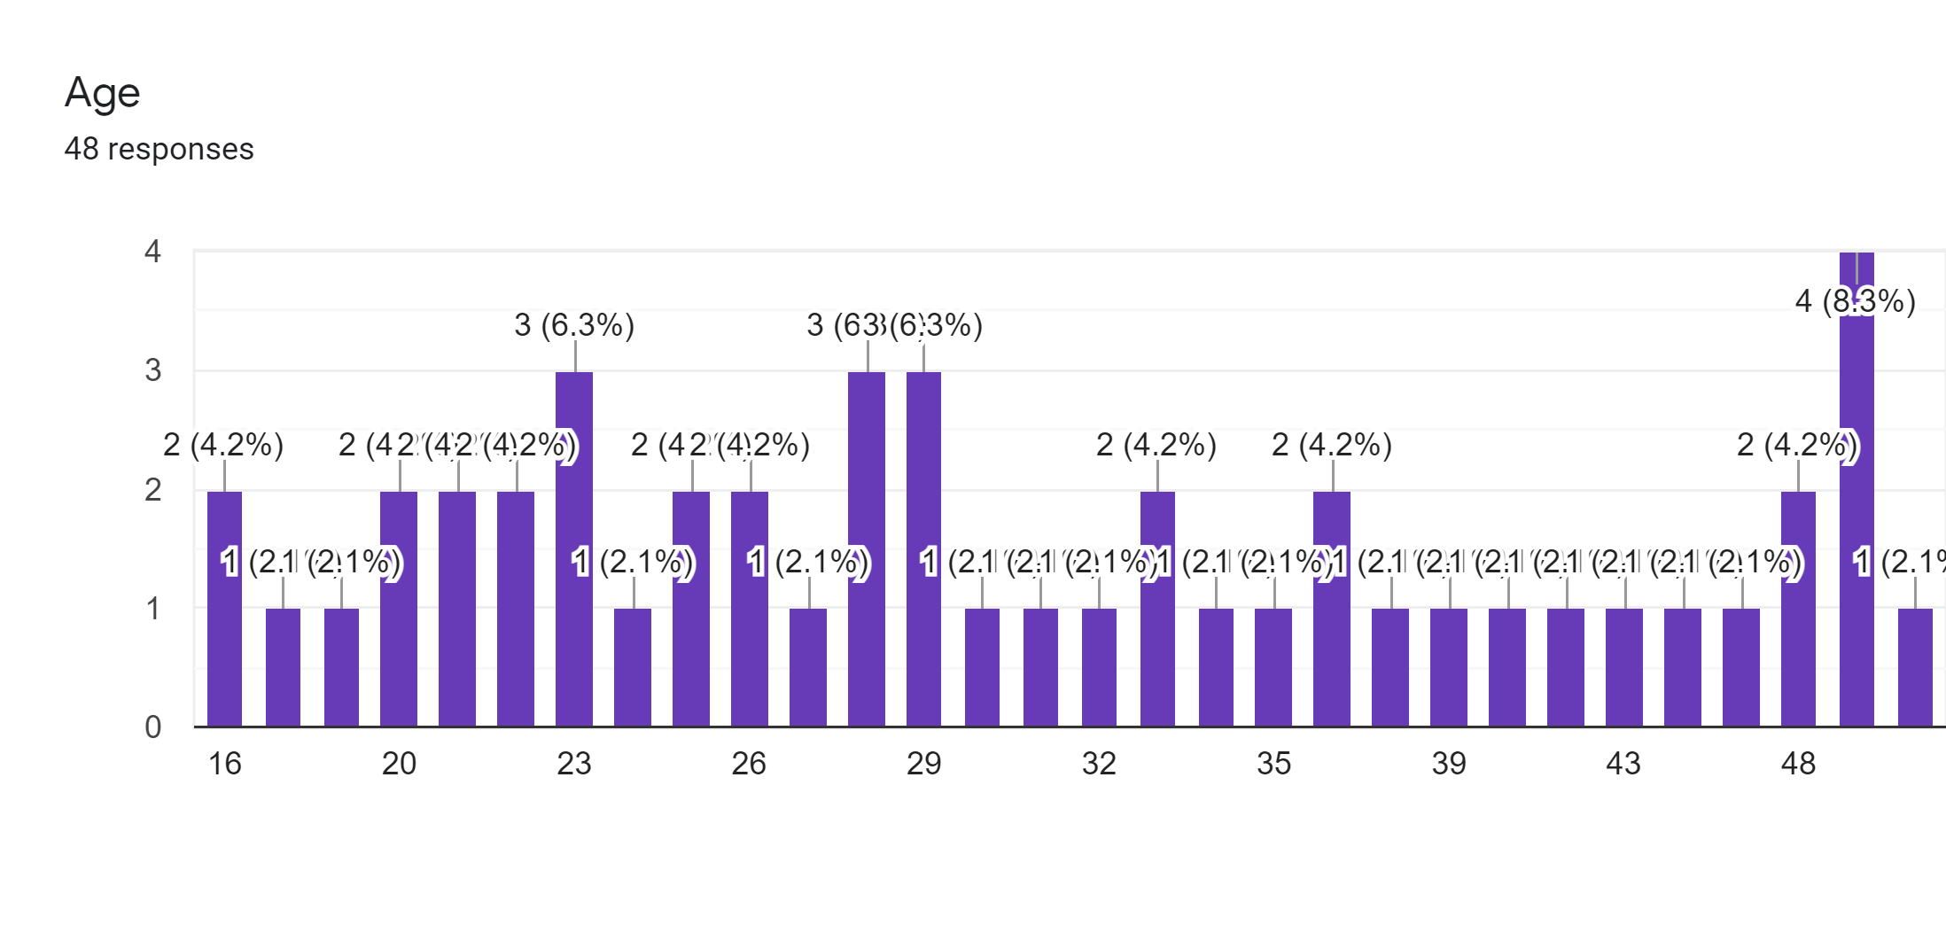

**Data Analysis:**

The following bar charts are the responses from different people from different parts of society and from different age groups.

**Note:**

Scale 1: Not important

Scale 2: Slightly important / Depends

Scale 3: Very Important

Here, in these graphs, as per responses from different types of people, it can be observed that all types of answers have been received in response to their personalities and their personal value set of ethics. Most people feel that Security as mail value as that is related to national security and still can see unity is alive and though the rest of the reviews on the other human values are quite interesting that different prospective have been displayed in the graph.

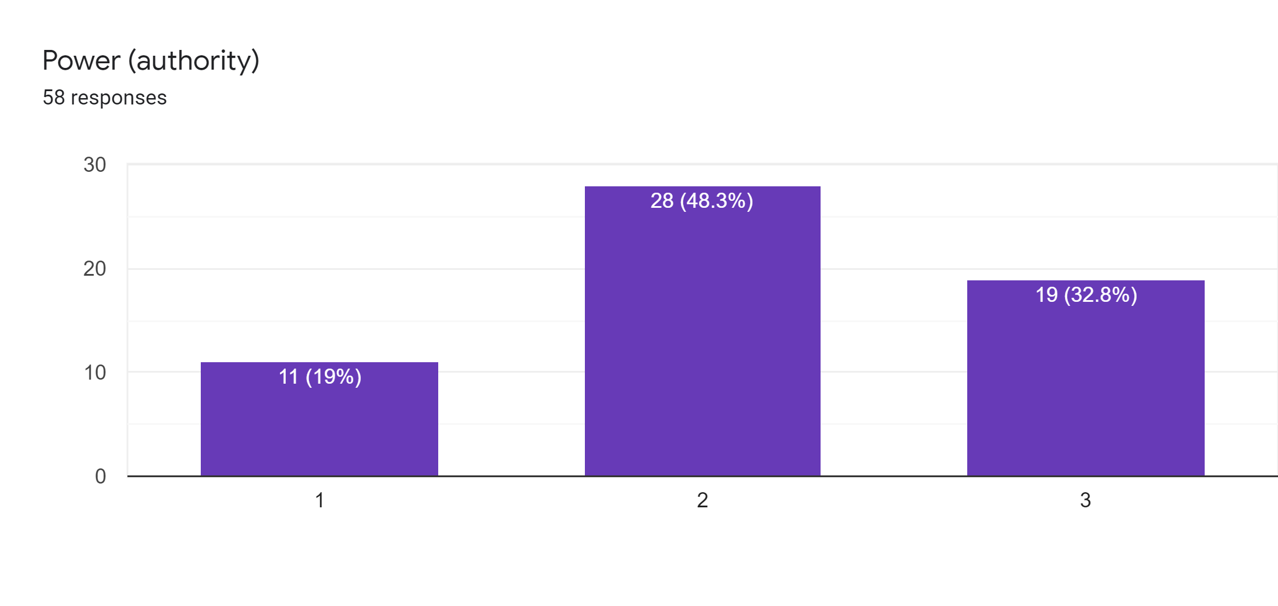

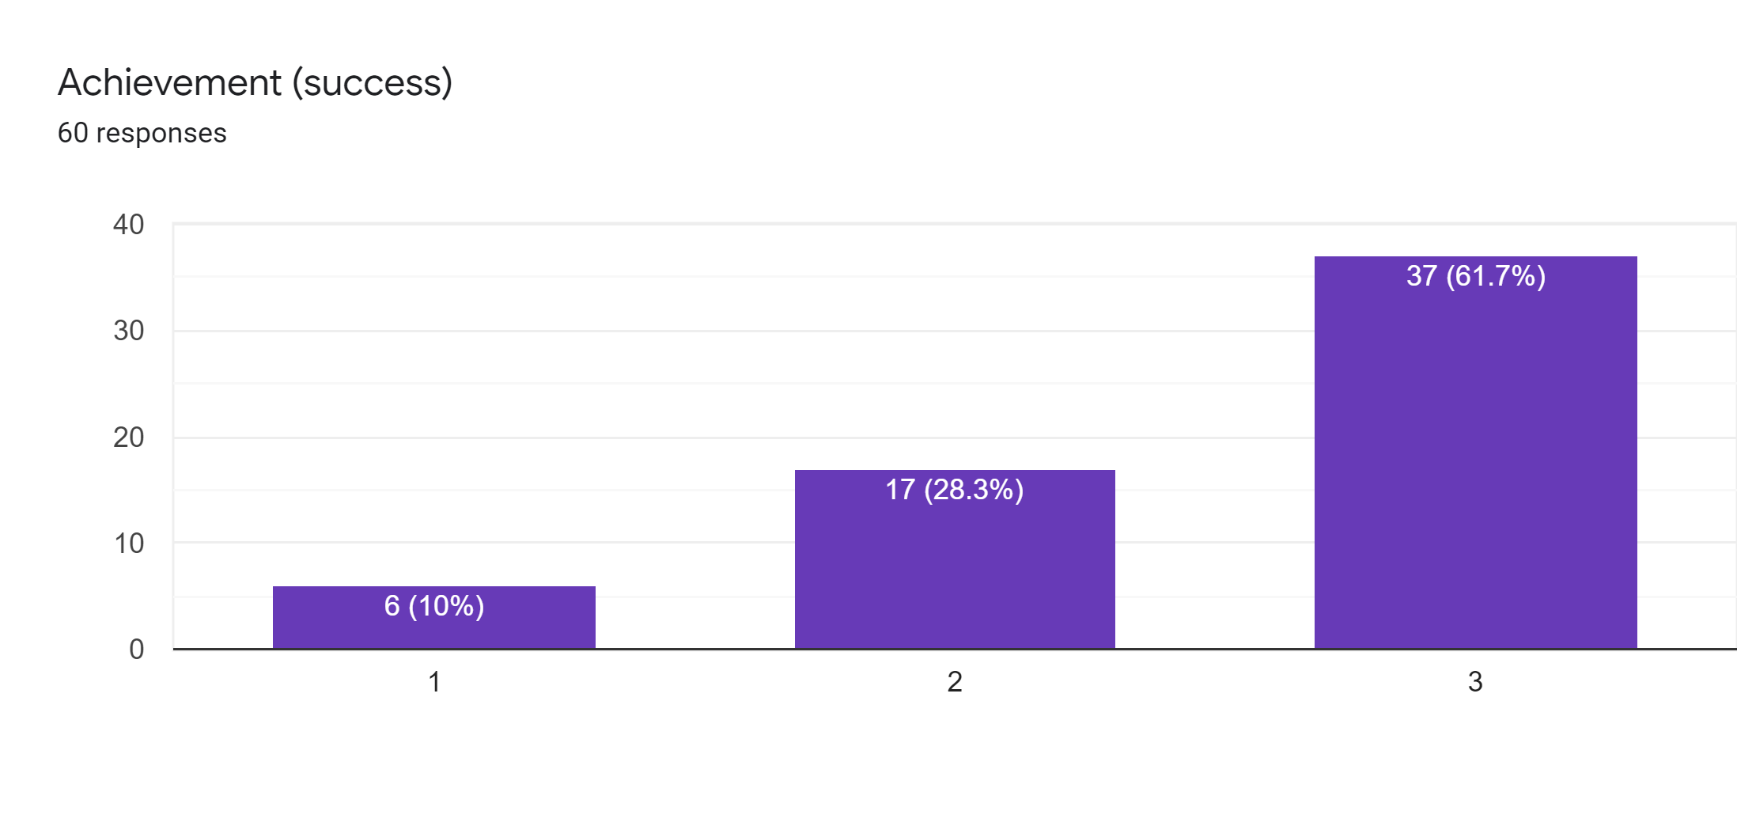

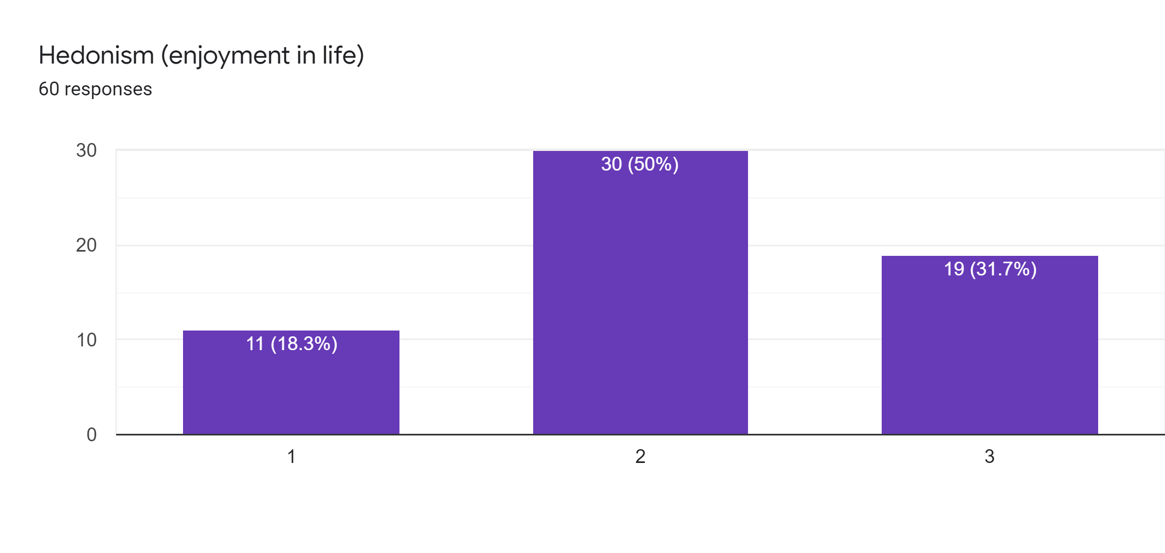

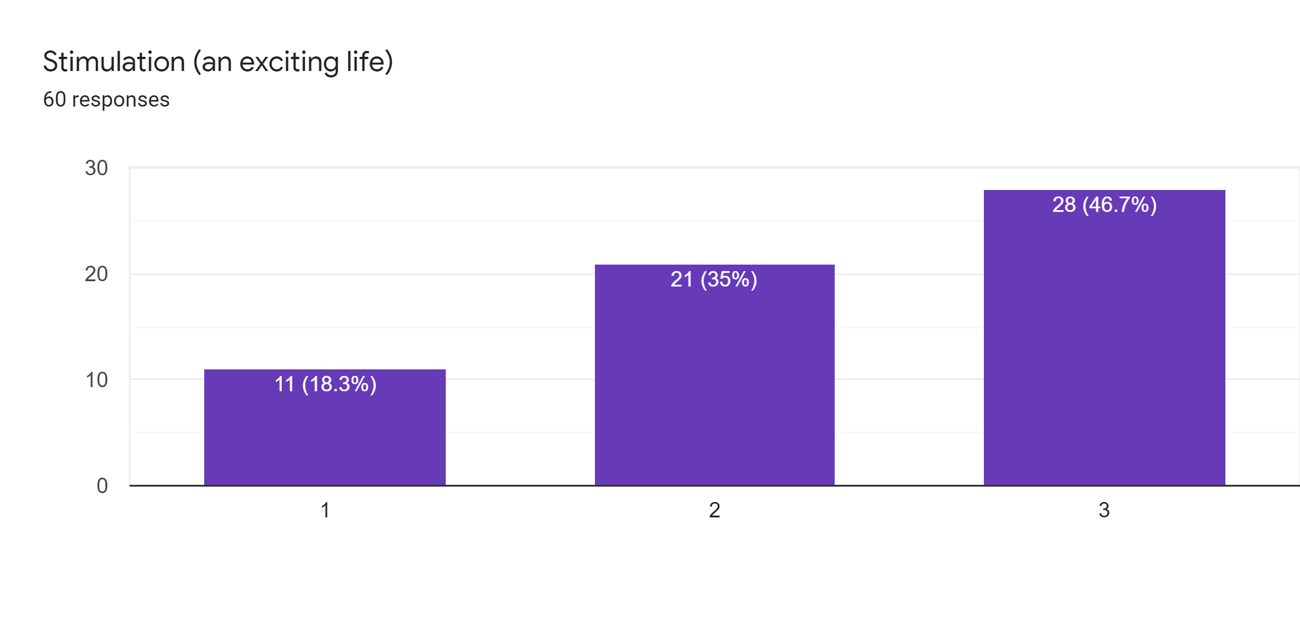

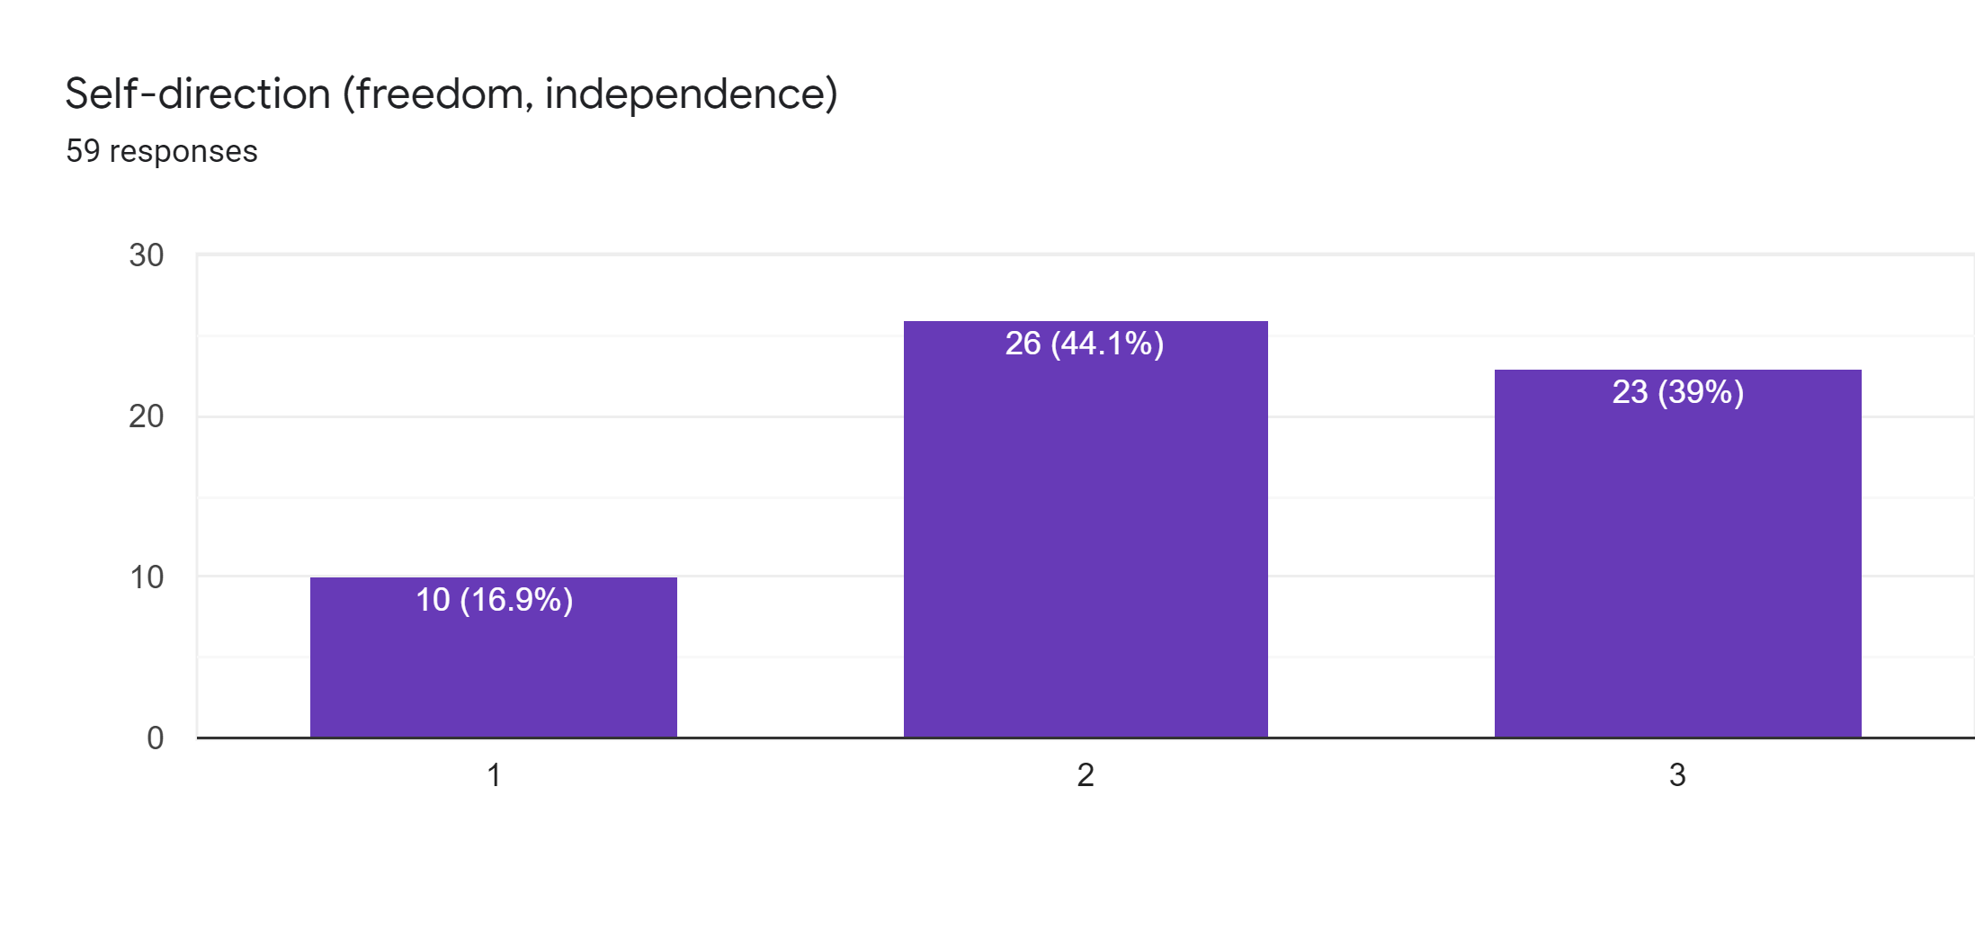

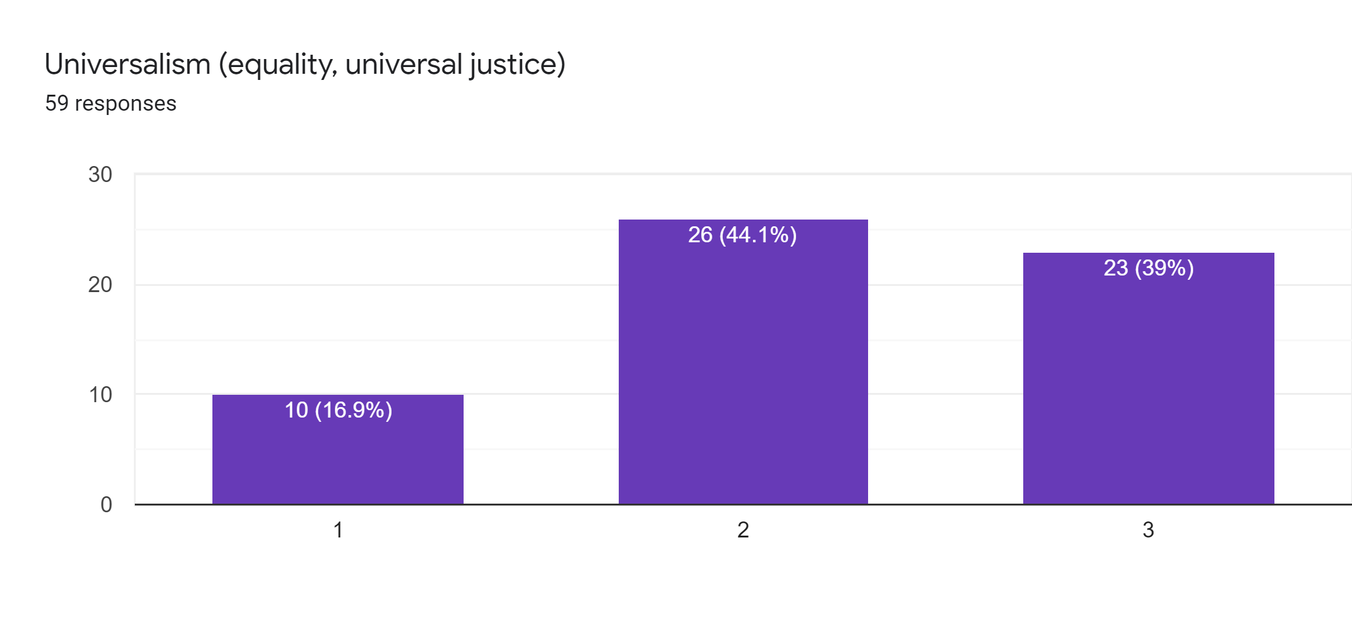

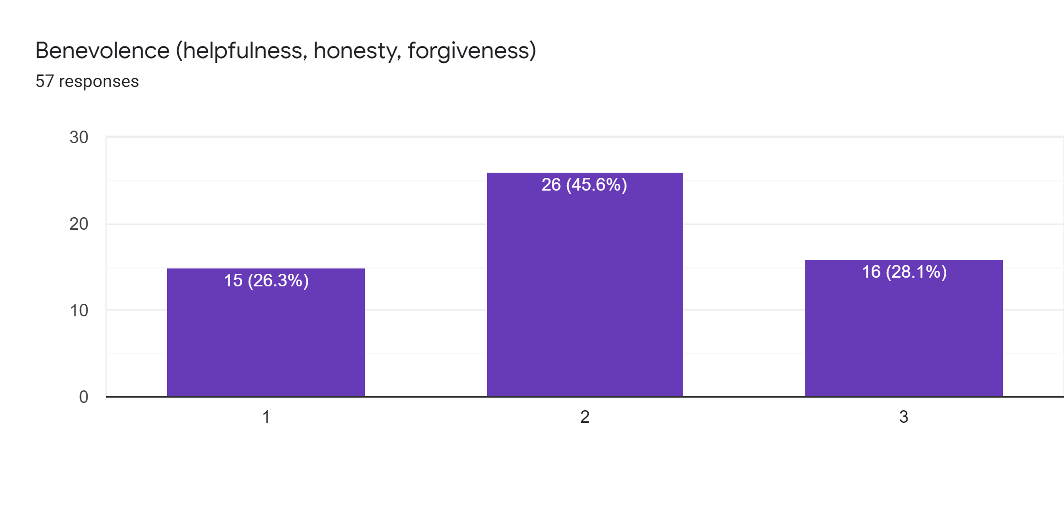

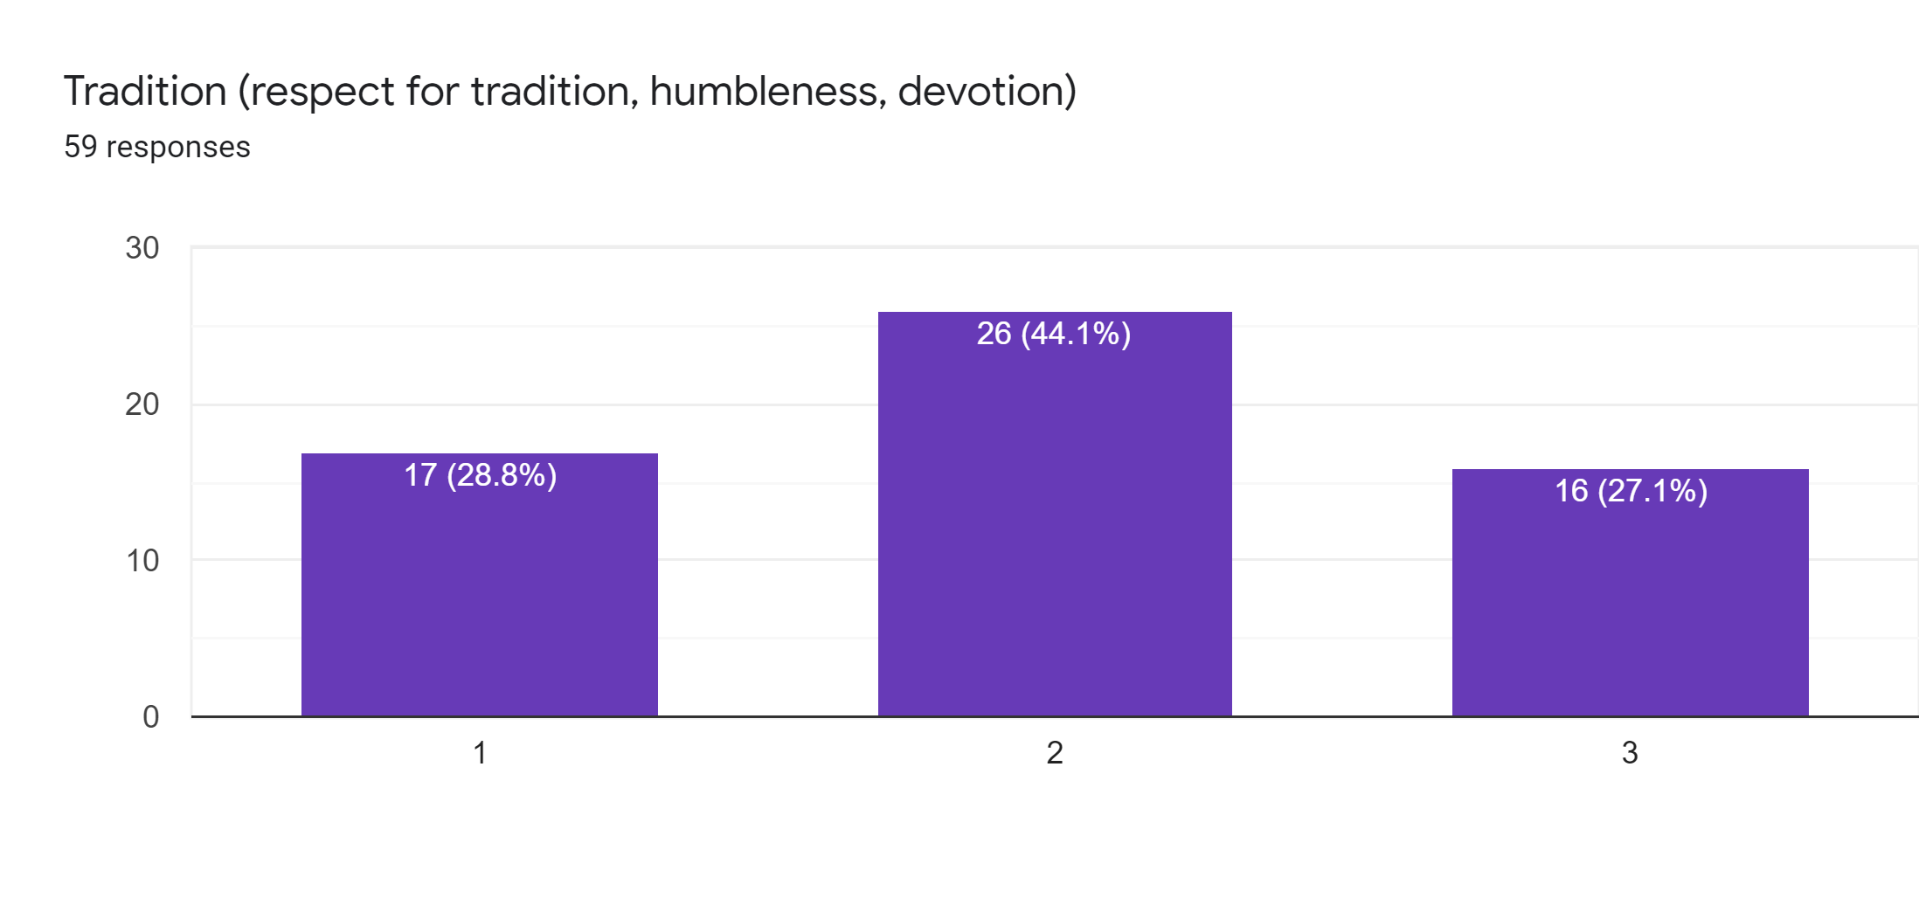

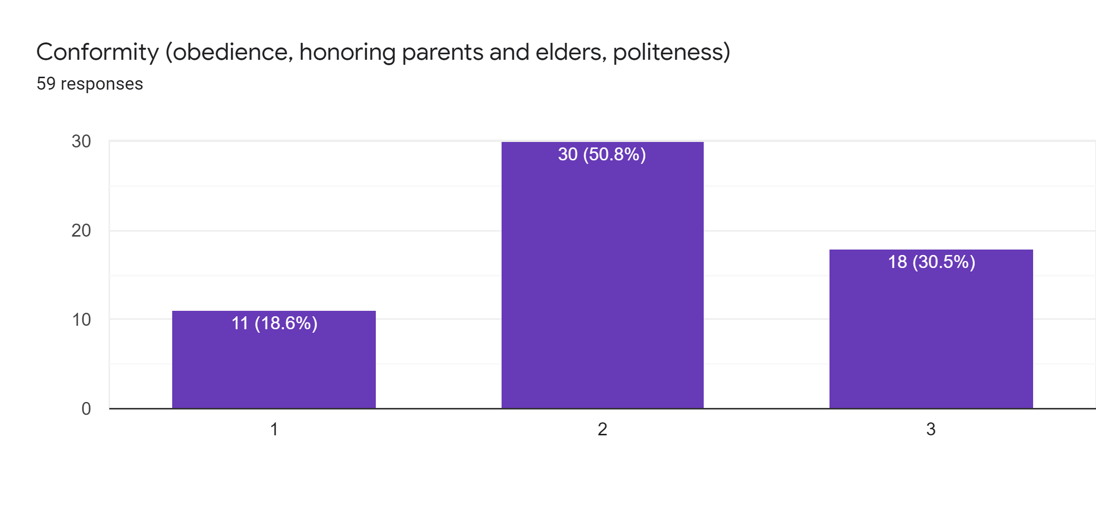

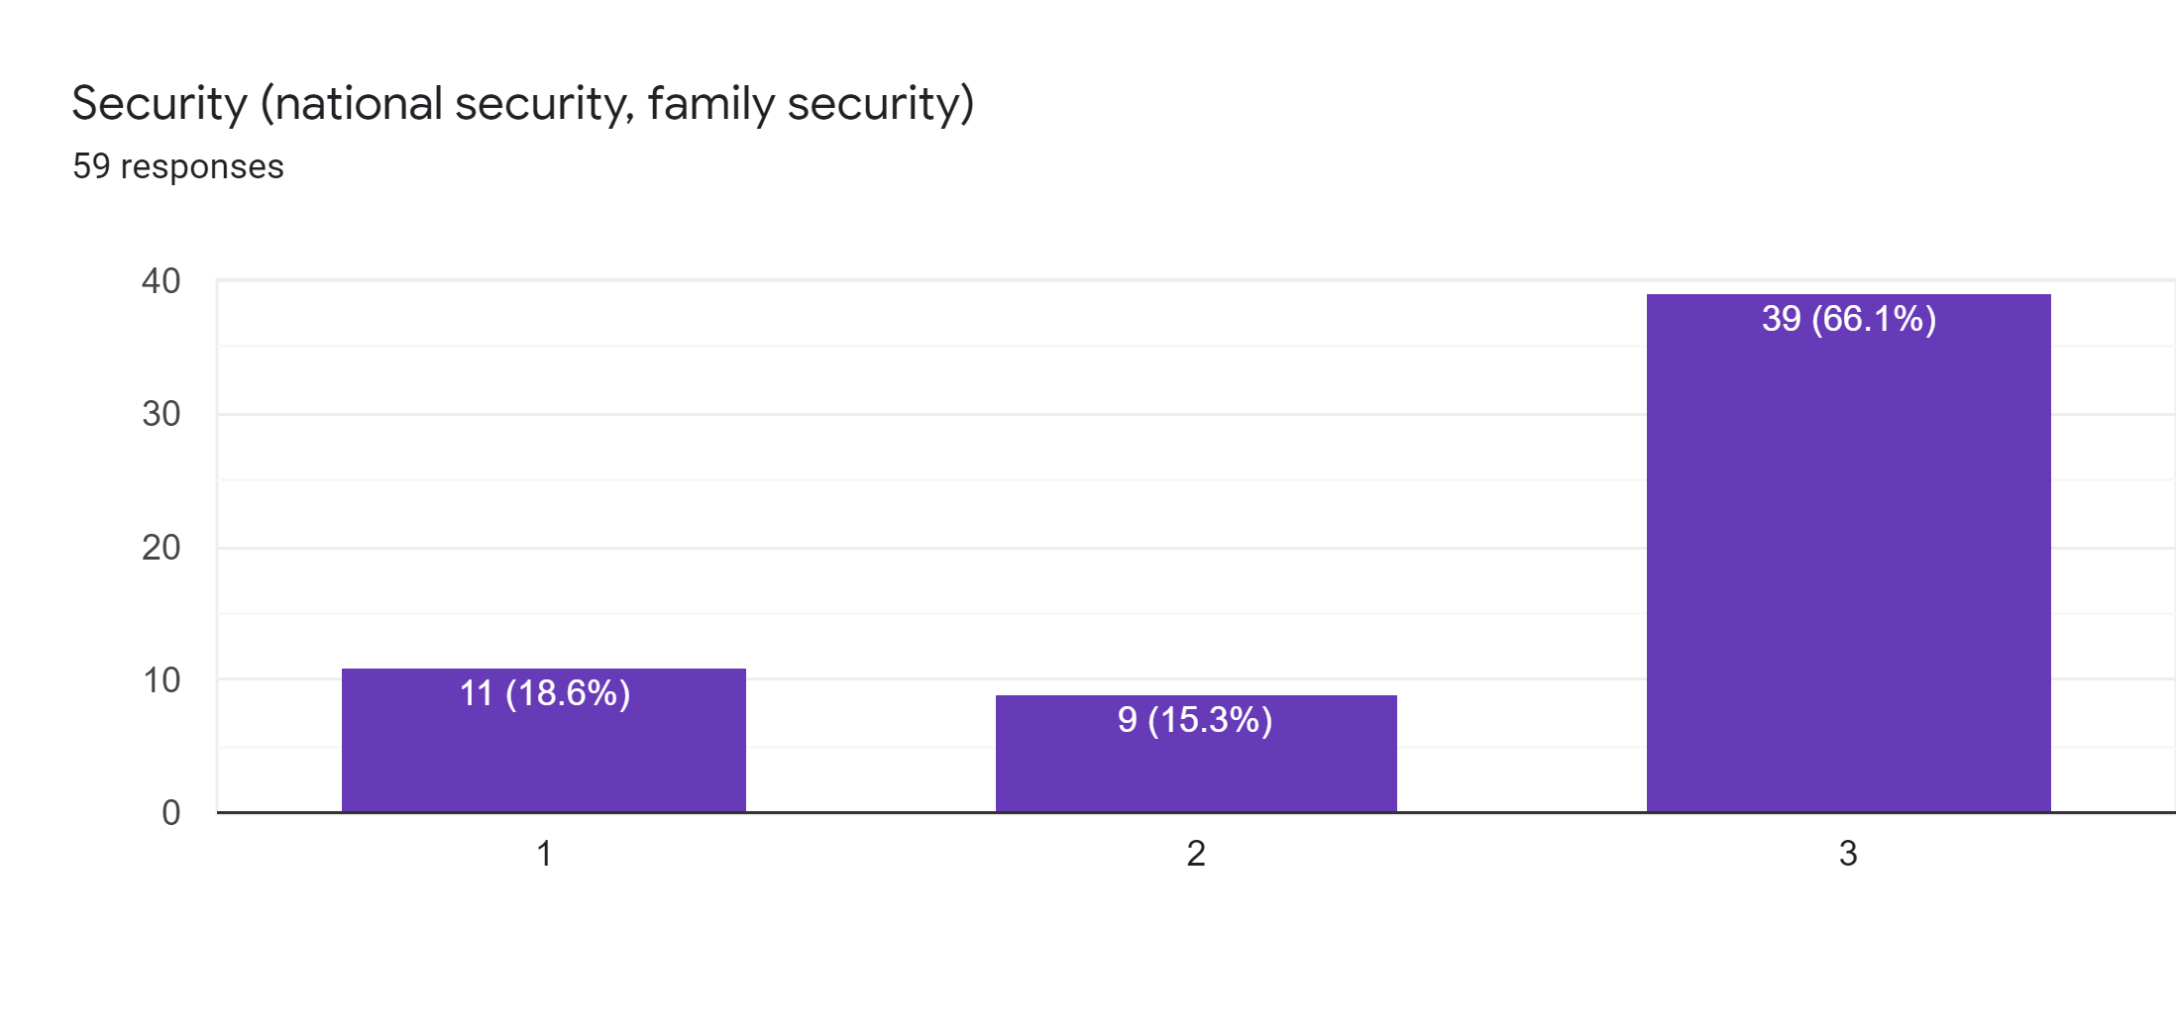

*Survey has been done based on

61 responses and findings come out to be that more people feel that Security and Achievement are good human values to be followed and the rest are to be depending upon their individual value set of ethics.

| **Human Value** | **Not important** | **Slightly important** | **Very important** |
| --- | --- | --- | --- |
| **Power** | 19% | 48.30% | 32.80% |
| **Achievement** | 10% | 28.30% | 61.70% |
| **Hedonism** | 18.30% | 50% | 31.70% |
| **Stimulation** | 18.30% | 35% | 46.70% |
| **Self-direction** | 16.90% | 44.10% | 39% |
| **Universalism** | 16.90% | 44.10% | 39% |
| **Benevolence** | 26.30% | 45.60% | 28.10% |
| **Tradition** | 28.80% | 44.10% | 27.10% |
| **Conformity** | 18.60% | 50.80% | 30.50% |
| **Security** | 18.60% | 15.30% | 60.10% |

**Conclusion:**

Social values, human values, and moral science are very substantive elements in the corporate lives of a society. With which a good society can’t be formed if these are missing. So, human values must be preserved for the upcoming generations to make the world a better place to live. Also, literature’s role in this process is the backbone to help the people learn about human values and build good relations with the society so that this would reduce a few problems like riots, wars, grudges, etc.… Anyhow, human values must be inculcated in humans in either way.

Human worth is a hypothesis concerning what things on the planet are acceptable, alluring, and significant. Current culture has been going through a huge emergency throughout the previous few decades. The well-established effortlessness, what's more, close ties between the family group and town collaboration are shriveling quicker. Globalization has not just prompted the trade of products and capitals yet additionally standards, values, and convictions. Along these lines, the force of "worldwide values" is overwhelming at this point. In every last one of us, there are values enrooted in the best pieces of our own selves from where we emanate it outwards. Human values might be treated as keys to handling worldwide issues. The viability of an individual relies upon two elements. One is abilities i.e., the capacity to accomplish something

that’s more, the other is the values inside that guide such activities. At the end of the day, but capable an individual may be, his commitment to the general public straightforwardly relies upon the values he has imitated. On account of negative values like self-image, outrage, eagerness, noxiousness, desire, and so on, the contribution of higher abilities in the shortfall of values will bring about cynical commitments to society as delinquent conduct. In cutting-edge time, we have extremely high abilities in every one of the circles. However, due decrease in the worth framework, the whole world is seeing a precarious ascent in pressures, weakness, despondency. This is bringing forth innumerable medical issues whether it is physical, enthusiastic, mental, or mental. Shallow endeavors stand crushed with regards to achieving enhancements. They should be enhanced with the teaching of values. The statement that Albert Einstein said many years prior stands important even today, Try not to turn into an individual of progress, yet rather attempt to happen to the individual of significant worth.

Human worth is a hypothesis concerning what things on the planet are acceptable, alluring, and important. Modern culture has been going through critical emergencies for the most recent couple of many years. Without a doubt, human values are presently shriveling extremely quickly for which we people are generally dependable. The deep-rooted straightforwardness and close ties among family and group and town co-activity are wilting quickly. The development of various current ideological groups among individuals and the all-out association of the majority in party legislative issues is a contributory element to such turn of events.

The advanced individuals currently imagine that their conventional socio-virtue is being undermined by the course of innovation. In this way, their customary social and moral framework and character are should have been saved by finding some kind of harmony between the conventional social and moral principles and the cutting edge esteems. Worth-based training ought to be stressed going from school to college level of instruction. They will quite often dismiss everything customary, their way of life, their religion, their God, their ethical quality, their values, their schooling, governmental issues, and so forth, in some cases they see their way of life as substandard compared to the elective models.

Human values assume an exceptionally driving part in the public arena. Human values overshadow social values. Human worth is the origination of humankind overall. The facts really confirm that the individual is the main concern, however, as long as people exist in the public arena, it very well might be solidly said that the cutting edge society won't ever grow out of its reality. Today with the innovative progression, correspondence has hugely improved, in this manner whatever that we say, do or even think will have an immediate bearing upon a bigger gathering of individuals. Today, papers educate us regarding such countless wrongdoings: burglary, murder, massacre, foul play, and political and financial defilement. These don't pass in large numbers of ardent perusers without making at minimum some kind of impact upon their lives. Movies and sound visuals have been the best impact. Accordingly, one can, at last, come to an end result that the ethical conduct of an individual or a gathering of people influences the general public at large. Therefore, human values assume a fundamental part of both the respectability and life span of any human culture (L.B. Mawrie, 2005).

Human worth is for the most part known to be an ethical norm of human conduct. Social and virtues are fundamental components of the aggregate existences of any local area without which the current present-day human culture will most likely be unable to keep on supporting. Hence, human values ought to be safeguarded and secured. Taking a gander at today’s human culture, one can see that it is profoundly immersed in realism. Human values are starting to lose their significance. The frenzy of realism has been very adverse to the customary social and moral framework. The soul of individual flexibility has achieved the corruption in the ethical existence of the human local area. Loss of moral respectability has consistently been liable for the annihilation of civilization before. There ought to be overall mindfulness being made by socio-social gatherings concerning the worth of customary traditions and legacy. Today, many explore and distributions ought to be done on a few parts of the general public which help to sustain the human upsides of the human local area in the post-present day period. Human values might be treated as keys to the arrangement of worldwide issues.

**References:**

A Textbook on Professional Ethics & Human Values, R.S.Naagarazan,2006, <https://soaneemrana.org/onewebmedia/Professional%20Ethics%20and%20Human%20Values%20by%20R.S%20NAAGARAZAN.pdf>

Aggarwal. J.C., Education For Values, Environment and Human Rights, 2016, <https://download.ei-ie.org/Docs/WebDepot/2016_RigaSymposium_BackgroundPaper_EN.pdf>

Academic Syllabus of Professional Ethics and Values by Dr.Vaishali Shinde, <https://drive.google.com/drive/u/2/folders/1tsqcMXdAMy1fQPNfDRSD5Pnpf_uDr7G_>